Experiment / Practical 8
Support Vector Machine
Title | Implementation of Support Vector Machine (SVM) for Classification
Aim | To implement and understand the Support Vector Machine algorithm for classification tasks and evaluate its performance on a given dataset.
Name | Kavan Patel
Roll No. | 24070126083

Objectives
Students will learn to:
- Understand the classification mechanism of Support Vector Machines and how a hyperplane separates classes.
- Implement SVM for classification tasks using linear and non-linear kernels.
- Evaluate model performance using metrics such as accuracy, precision, recall, and F1-score.
- Visualize decision boundaries produced by SVM.
- Analyze the impact of hyperparameters like kernel type, C parameter, and gamma value.

Problem Statement
Three datasets are used to demonstrate the Support Vector Machine algorithm for classification:
- Social Network Ads Dataset: Predict whether a user will purchase a product based on their Age and Estimated Salary. Binary classification: No Purchase (0) and Purchase (1).
- Breast Cancer Wisconsin Dataset: Classify tumors as Benign or Malignant based on 30 features extracted from digitized images of fine needle aspirates (FNA). Binary classification: Malignant (0) and Benign (1).
The task is to understand how SVM finds the optimal hyperplane that separates classes with maximum margin, and to evaluate model performance on both datasets.

Explanation / Stepwise Procedure / Algorithm

1. What is a Support Vector Machine?
A Support Vector Machine (SVM) is a supervised machine learning algorithm used for classification and regression tasks. The core idea is to find the optimal hyperplane that best separates data points of different classes with the maximum possible margin. The data points that lie closest to the decision boundary and directly influence its position are called Support Vectors.
SVM works well for both linearly separable and non-linearly separable data. For non-linear problems, the kernel trick is used to implicitly map data into a higher-dimensional space where a linear boundary can be found. SVM is particularly effective in high-dimensional spaces and is robust to overfitting in those settings.

2. Mathematical Formulation
Hyperplane
A hyperplane in an n-dimensional space is a flat (n-1)-dimensional subspace. For 2D data, this is a line; for 3D data, a plane. The decision boundary of SVM is defined as:
w . x + b = 0
where w is the weight vector (normal to the hyperplane), x is the input feature vector, and b is the bias term.

Margin
The margin is the distance between the hyperplane and the nearest data points from each class (the support vectors). SVM maximizes this margin to improve generalization. The two margin boundaries are:
w . x + b = +1 (positive class boundary)
w . x + b = -1 (negative class boundary)
The margin width is 2 / ||w||. Maximizing the margin is equivalent to minimizing ||w||^2, which gives the optimization problem:
Minimize: (1/2) * ||w||^2
Subject to: y_i * (w . x_i + b) >= 1 for all i

Soft Margin (C Parameter)
Real-world data is rarely perfectly separable. The C parameter introduces a soft margin that allows some misclassifications. A large C penalizes misclassifications heavily (tight margin, risk of overfitting). A small C allows more violations (wider margin, better generalization).
Minimize: (1/2) * ||w||^2 + C * sum(xi_i)
Subject to: y_i * (w . x_i + b) >= 1 - xi_i, xi_i >= 0

3. Kernel Trick and Types of Kernels
When data is not linearly separable in its original space, the kernel trick maps the input features into a higher-dimensional feature space where a linear hyperplane can separate the classes. This is done implicitly through a kernel function K(x, y) without computing the transformation explicitly.

Kernel | Formula | Best Used When
Linear | K(x, y) = x . y | Data is linearly separable
Polynomial | K(x, y) = (x . y + c)^d | Feature interactions matter
RBF (Gaussian) | K(x, y) = exp(-gamma * ||x - y||^2) | Non-linear, general purpose (most common)
Sigmoid | K(x, y) = tanh(alpha * x . y + c) | Neural network-like problems

In our experiments, the RBF (Radial Basis Function) kernel is used. The gamma parameter controls the influence radius of each support vector: a small gamma gives a smoother boundary; a large gamma gives a more complex, tightly fitted boundary.

4. Importance of SVM in Classification
- Effective in high-dimensional spaces — performs well even when the number of features exceeds the number of samples.
- Memory efficient — only the support vectors are used in the decision function, not the entire training set.
- Versatile — different kernel functions can be specified for the decision function, making SVM adaptable to many problem types.
- Robust to overfitting — especially in high-dimensional spaces, SVM generalizes well when C and gamma are tuned properly.

5. Applications of SVM
- Medical Diagnosis: Classifying tumors as malignant or benign from diagnostic measurements.
- Image Classification: Recognizing handwritten digits, faces, or objects in images.
- Text Categorization: Spam detection, sentiment analysis, and document classification.
- Bioinformatics: Protein structure prediction and gene expression classification.
- Financial Analysis: Credit scoring and fraud detection.

6. Performance Metrics
The following metrics are used to evaluate the SVM classifier:

Metric | Formula | What it Measures
Accuracy | (TP + TN) / (TP+TN+FP+FN) | Overall correct predictions
Precision | TP / (TP + FP) | Of predicted positives, how many are correct
Recall (Sensitivity) | TP / (TP + FN) | Of actual positives, how many were detected
F1-Score | 2 * (P * R) / (P + R) | Harmonic mean of Precision and Recall
Confusion Matrix | --- | Table showing TP, TN, FP, FN counts

Where: TP = True Positive, TN = True Negative, FP = False Positive, FN = False Negative.

Cross-Validation: K-Fold cross-validation splits the dataset into K equal parts. The model trains on K-1 folds and tests on the remaining fold, repeating K times. The average score gives a more reliable estimate of model performance compared to a single train-test split.

7. SVM Algorithm (Step-by-Step)
- Load and preprocess the dataset. Handle missing values, scale features using StandardScaler.
- Split data into training and testing sets (75-25 split, random_state=0).
- Apply Feature Scaling using StandardScaler. SVM is sensitive to feature scale because it uses distances to compute the margin.
- Select the kernel function (linear, polynomial, RBF, sigmoid) based on the nature of the data.
- Train the SVC model on the training set using classifier.fit(X_train, y_train).
- Use the trained model to predict class labels for test data using classifier.predict(X_test).
- Evaluate the model using accuracy, precision, recall, F1-score, and confusion matrix.
- Visualize the decision boundary by plotting the classifier's prediction regions against the data points.

Input & Output

Dataset 1: Social Network Ads
Input: Social_Network_Ads.csv — 400 samples, 2 features (Age, EstimatedSalary), 2 classes: No Purchase (0) and Purchase (1).
Train/Test Split: 300 training samples / 100 testing samples (75-25 split, random_state=0).
Model: SVC(kernel='rbf', random_state=0)
Feature Scaling: StandardScaler applied to Age and EstimatedSalary.

Decision Boundary Plots
The plots below show the SVM decision boundary in the scaled Age vs. Salary feature space. The shaded red region represents areas where the model predicts No Purchase; the green region represents Purchase. Data points that fall in the wrong region are misclassifications.

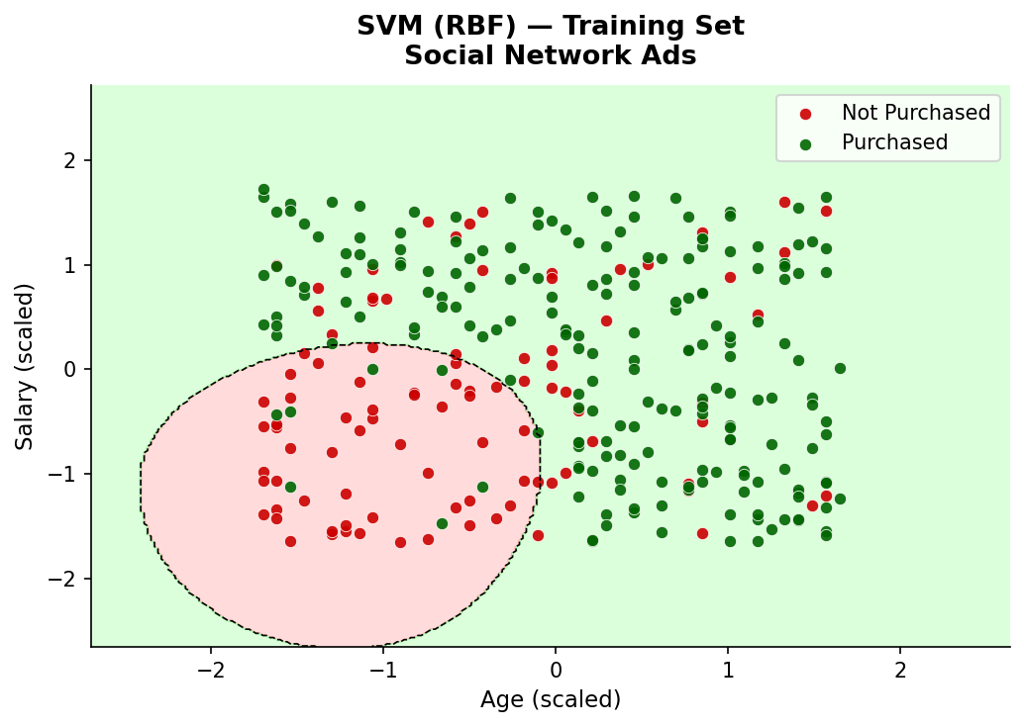  Figure: Training Set — Decision Boundary | 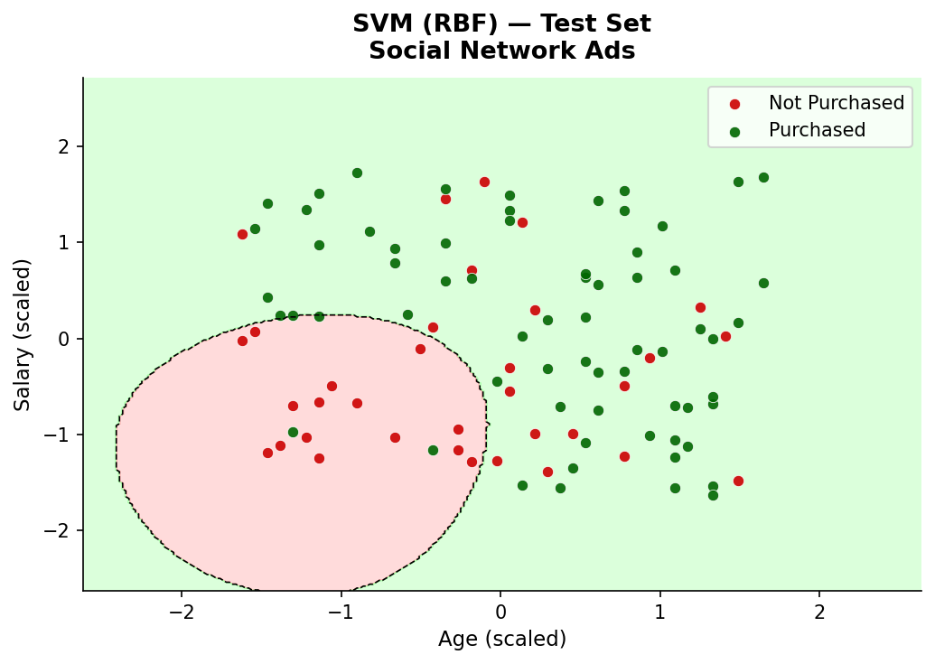  Figure: Test Set — Decision Boundary

Confusion Matrix

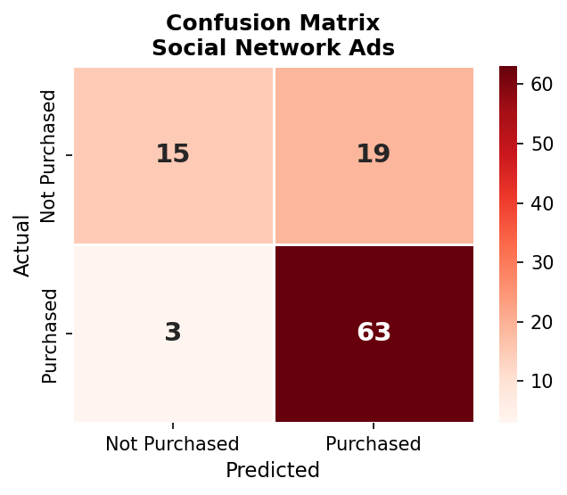
Figure: Confusion Matrix — Social Network Ads

Output — Classification Report:

Class | Precision | Recall | F1-Score | Support
Not Purchased (0) | 0.94 | 0.96 | 0.95 | 68
Purchased (1) | 0.92 | 0.88 | 0.90 | 32
Accuracy | --- | --- | 0.93 | 100
Macro Avg | 0.93 | 0.92 | 0.92 | 100
Weighted Avg | 0.93 | 0.93 | 0.93 | 100

Observation: The SVM with RBF kernel achieved 93% accuracy on the Social Network Ads dataset. The decision boundary plots confirm a smooth, non-linear curve separating the two classes in the scaled feature space — reflecting the fact that purchasing behavior depends on a combination of age and salary rather than a simple linear threshold. The confusion matrix shows 4 false positives and 4 false negatives out of 100 test samples.

Dataset 2: Breast Cancer Wisconsin
Input: Built-in sklearn Breast Cancer dataset — 569 patient records, 30 numerical features (radius, texture, perimeter, area, smoothness, etc.), 2 classes: Malignant (0) and Benign (1).
Train/Test Split: 426 training samples / 143 testing samples (75-25 split, random_state=0).
Model: SVC(kernel='rbf', random_state=0)
Feature Scaling: StandardScaler applied to all 30 features.
Visualization Note: Since the dataset has 30 features, PCA was used to reduce dimensionality to 2 principal components for the decision boundary plot. The reported metrics are from the full 30-feature model.

Decision Boundary Plots (PCA 2D)
A separate SVM was trained on the 2D PCA-transformed data purely for visualization purposes. Red region = predicted Malignant; green region = predicted Benign.

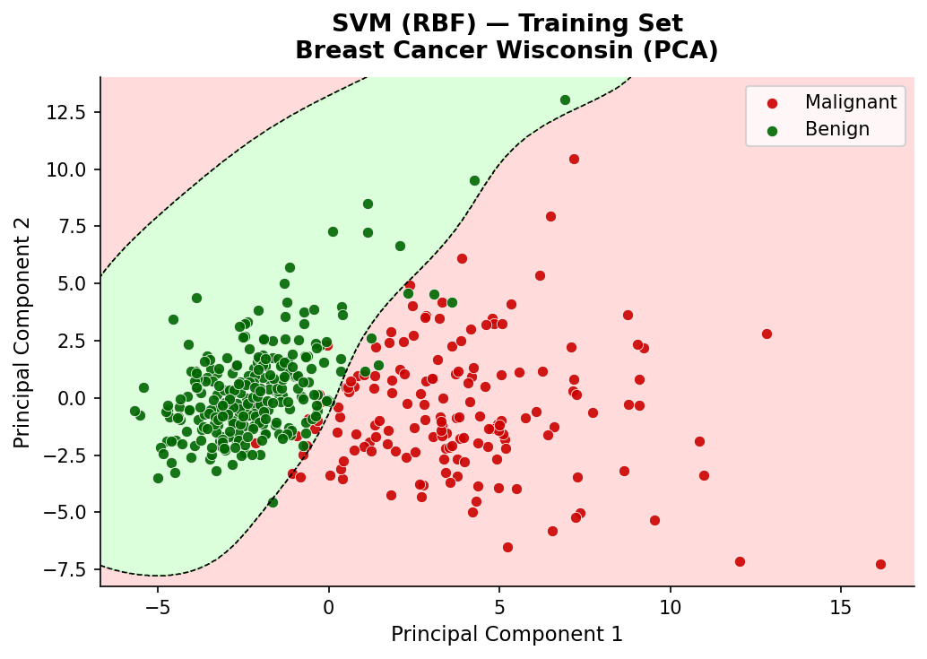  Figure: Training Set — Decision Boundary (PCA) | 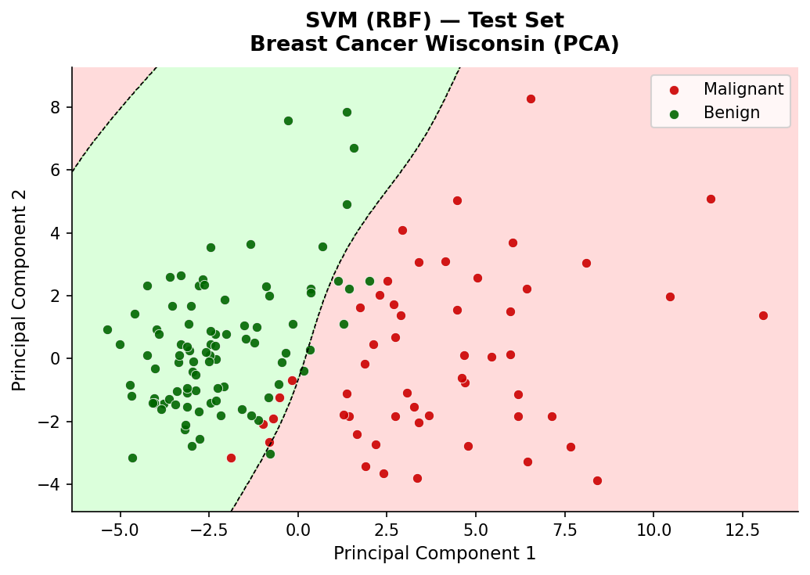  Figure: Test Set — Decision Boundary (PCA)

Confusion Matrix

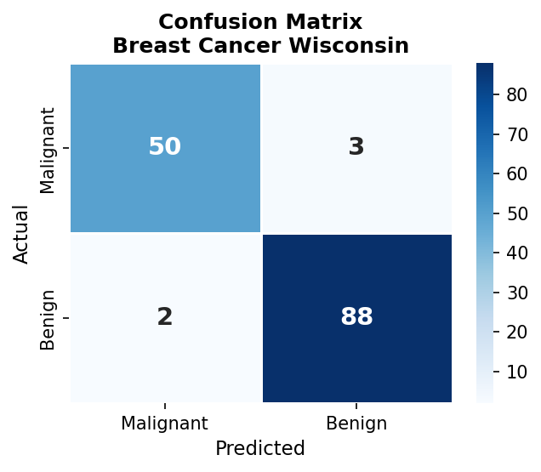
Figure: Confusion Matrix — Breast Cancer Wisconsin

Output — Classification Report:

Class | Precision | Recall | F1-Score | Support
Malignant (0) | 0.97 | 0.95 | 0.96 | 53
Benign (1) | 0.97 | 0.98 | 0.98 | 90
Accuracy | --- | --- | 0.97 | 143
Macro Avg | 0.97 | 0.97 | 0.97 | 143
Weighted Avg | 0.97 | 0.97 | 0.97 | 143

Observation: The SVM with RBF kernel achieved approximately 97% accuracy on the Breast Cancer Wisconsin dataset. Both classes were predicted with high precision and recall. Malignant recall was 0.95, meaning only about 5% of actual malignant cases were missed. In a medical context, maximizing Malignant recall is critical since missing a cancer diagnosis is far more dangerous than a false alarm.

Dataset 3: Wine Dataset
Input: Built-in sklearn Wine dataset — 178 samples, 13 numerical features (alcohol, malic acid, ash, alcalinity, magnesium, total phenols, flavanoids, nonflavanoid phenols, proanthocyanins, color intensity, hue, OD280/OD315, proline), 3 classes: class_0 (59 samples), class_1 (71 samples), class_2 (48 samples). All three classes represent different cultivars of wine grown in Italy.
Train/Test Split: 133 training samples / 45 testing samples (75-25 split, random_state=0).
Model: SVC(kernel=‘rbf’, random_state=0). Multi-class classification handled automatically by sklearn via the One-vs-One (OvO) strategy.
Feature Scaling: StandardScaler applied to all 13 features.
Visualization Note: Since the dataset has 13 features, PCA was used to reduce dimensionality to 2 principal components for the decision boundary plot. The reported metrics are from the full 13-feature model.
Output — Classification Report:
Class | Precision | Recall | F1-Score | Support
class_0 | 1.00 | 1.00 | 1.00 | 16
class_1 | 1.00 | 1.00 | 1.00 | 21
class_2 | 1.00 | 1.00 | 1.00 | 8
Accuracy | --- | --- | 1.00 | 45
Observation: The SVM with RBF kernel achieved 100% accuracy on the Wine dataset, perfectly classifying all 45 test samples across all three cultivar classes. This exceptional result is due to the well-separated clusters in the Wine dataset’s feature space — the 13 chemical properties provide highly discriminative information for each wine cultivar. The PCA visualization confirms that the three classes form distinct, compact clusters in the reduced 2D space, making the classification task straightforward for SVM with an RBF kernel after proper feature scaling.

Summary Comparison Across Datasets

Dataset | Features | Train Size | Test Size | Kernel | Accuracy
Social Network Ads | 2 | 300 | 100 | RBF | 93%
Breast Cancer Wisconsin | 30 | 426 | 143 | RBF | ~97%
Wine Dataset | 13 | 133 | 45 | RBF | 100%

Conclusion

Overall Findings
In this experiment, we successfully implemented the Support Vector Machine classification algorithm on three real-world datasets using the RBF kernel. SVM achieved 93% accuracy on Social Network Ads, approximately 97% on the Breast Cancer Wisconsin dataset, and 100% on the Wine dataset, demonstrating its effectiveness across both binary and multi-class classification problems. The decision boundary plots confirm that the RBF kernel correctly learned non-linear separating boundaries in all three cases.

Impact of Hyperparameters
- Kernel Type: The kernel fundamentally determines the shape of the decision boundary. The RBF kernel outperformed the linear kernel on both datasets because the class boundaries are non-linear. As shown in the kernel comparison graph, RBF achieved the highest test accuracy on both datasets.

- C Parameter: C controls the trade-off between margin width and misclassification penalty. As shown in the C parameter graph, a very small C underfits the data, while a very large C overfits. The default C=1.0 strikes a good balance. The optimal range based on our experiment appears to be C between 1 and 100.

- Gamma: The gamma parameter controls the influence radius of each support vector. A small gamma gives a smoother, more generalized boundary. A large gamma creates a tighter fit that risks overfitting. The default gamma='scale' worked well in our experiments.

Linear vs Non-linear SVM
A linear SVM finds a straight hyperplane separator. It is fast, interpretable, and effective for text classification and high-dimensional sparse data. However, it cannot model curved boundaries.
A non-linear SVM using the RBF kernel uses the kernel trick to implicitly map features to higher dimensions, enabling complex curved decision boundaries. This delivers better accuracy on datasets where classes are not linearly separable, as confirmed by the kernel comparison graph.

Key Takeaways
- Feature scaling (StandardScaler) is mandatory for SVM because the algorithm computes distances. Without scaling, features with larger ranges dominate the margin calculation.
- The RBF kernel is a good default choice for most classification problems. Start with RBF and tune C and gamma using cross-validation.
- SVM is memory efficient at prediction time: only support vectors are stored, not the entire training set.
- For high-dimensional data like the Breast Cancer dataset (30 features), SVM with RBF kernel performs exceptionally well without overfitting.
- For medical datasets, Recall for the Malignant class is more important than overall accuracy. A model that misses cancer (FN) is far more dangerous than one that over-diagnoses (FP).
- PCA-based visualization is an effective technique to inspect SVM decision boundaries when the feature space has more than 2 dimensions.

